NAME – MUNTASIR RAHAMAN SIRKHAZI
MATRIX NO- A23MJ0013
PROJECT
Video dhl demo-https://youtu.be/V_BlhNJVmkA

- Home page: -
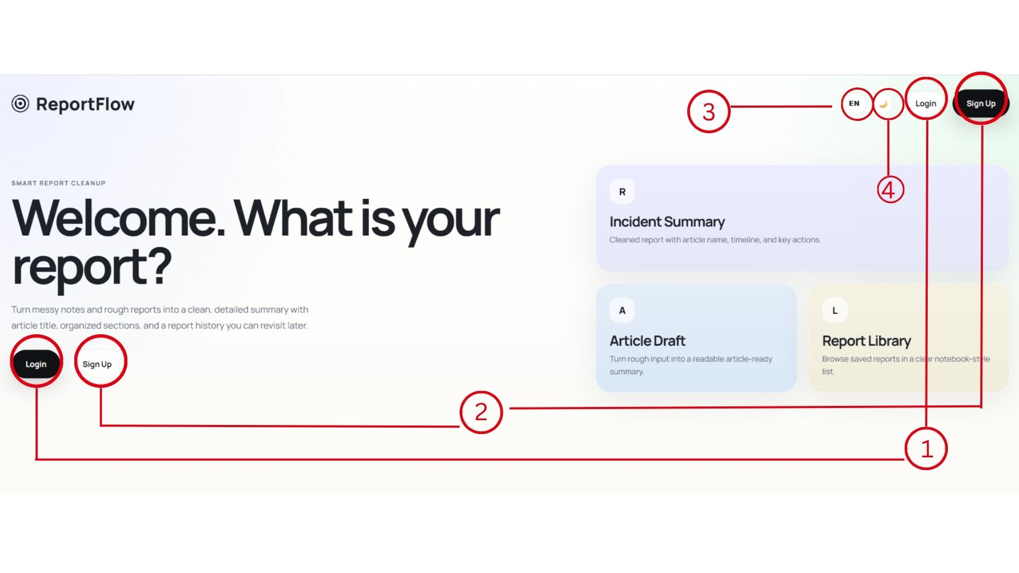
This page is the ReportFlow welcome/home page. It is the first screen users see before they start using the report tool.
Main purpose:
It asks the user, “Welcome. What is your report?” This means the website is ready for the user to create or manage a report.
The page has these main parts:
.
- Login in the page
These buttons appear in the main area so users can quickly choose whether they want to log in
- Sign up button
The Sign-up button is for new users who do not have an account yet. They can create a new account by clicking it
- Language option
The small “EN” button means the website language is currently English. Users may click it to change the language to Malaya.
- Theme / mode button
The moon icon likely changes the page theme, such as switching between light mode and dark mode.

- Sign-Up Page: -
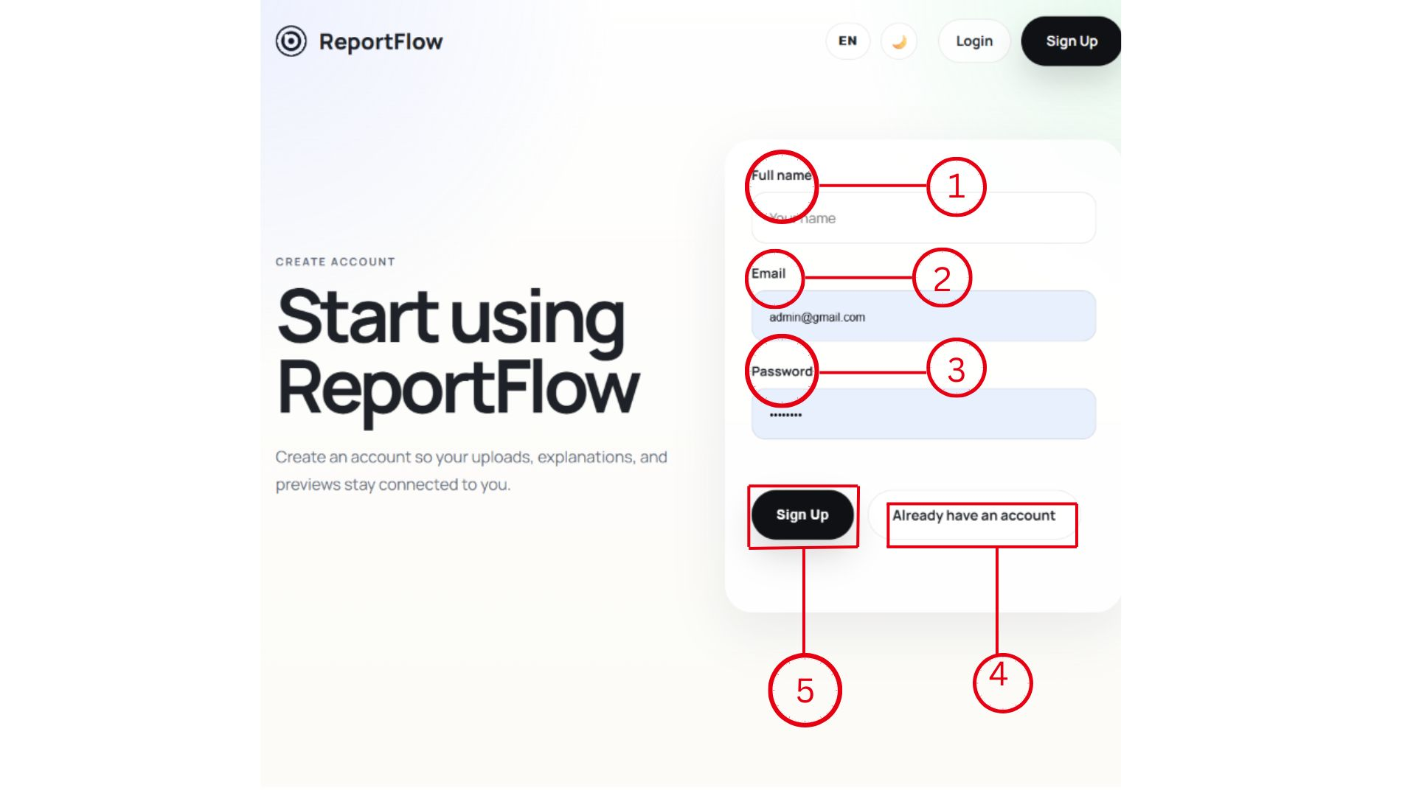
This is the Report Flow sign up page. It is used to create a new account so the user’s reports, uploads, explanations, and previews can be saved.
- Full name
The user enters their full name here.
- Email
The user enters their email address here. This email will likely be used for logging in later.
- Password
The user creates a password here. The dots show that the password is hidden for privacy.
- Already have an account
This button/link is for users who already created an account. Clicking it should take them to the login page.
- Sign Up button
After filling in the full name, email, and password, the user clicks Sign Up to create the account.
- Login page: -
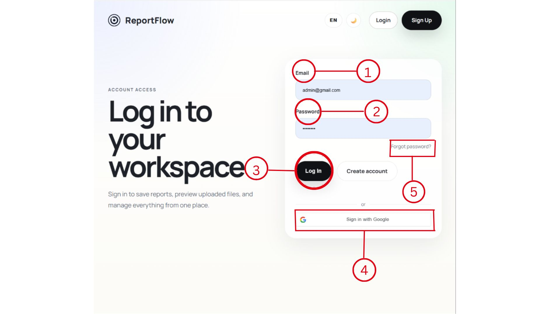
This is the ReportFlow login page. It is used when a user already has an account and wants to access their workspace.
- Email
The user enters their email address here.
- Password
The user enters their password here. The dots hide the password for privacy.
- Log In button
After entering the email and password, the user clicks Log In to access their account.
- Sign in with Google
This button lets the user log in using their Google account instead of typing an email and password.
- Forgot password?
This link is for users who forgot their password. Clicking it should help them reset or recover their password.
There is also a Create account button. This is for users who do not have an account yet and need to sign up first.
- Forgot password page: -
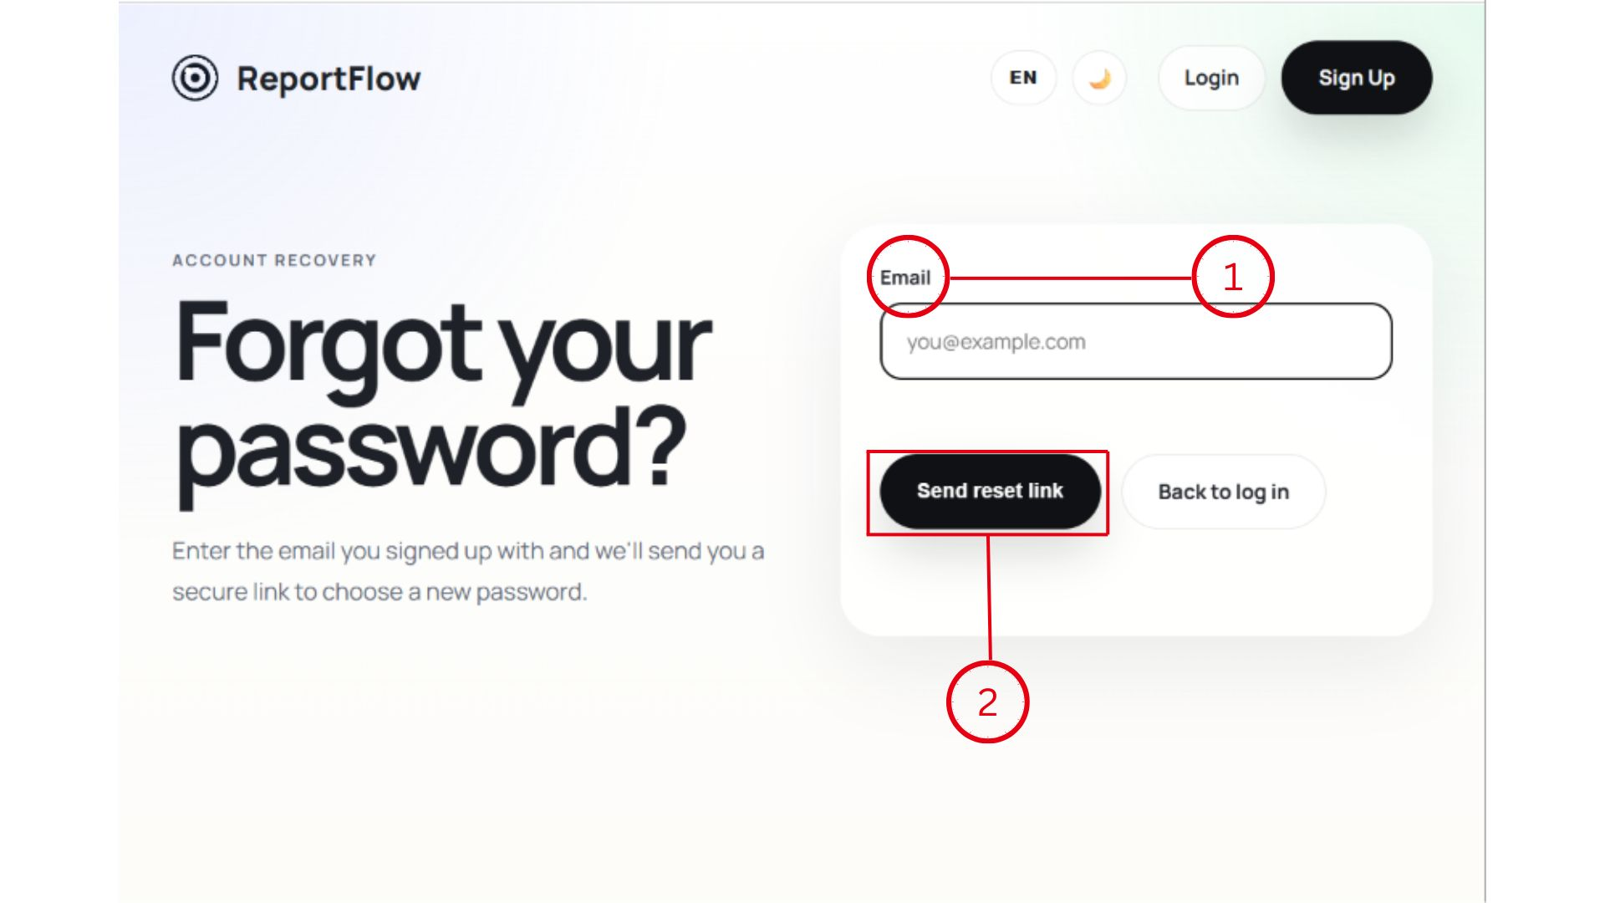
This is the ReportFlow account recovery page. It is used when a user forgets their password and needs to reset it.
- Email
The user enters the email address they used to create their ReportFlow account.
- Send reset link button
After entering the email, the user clicks Send reset link. The system should send a secure password reset link to that email address.
There is also a Back to log in button. This takes the user back to the normal login page.
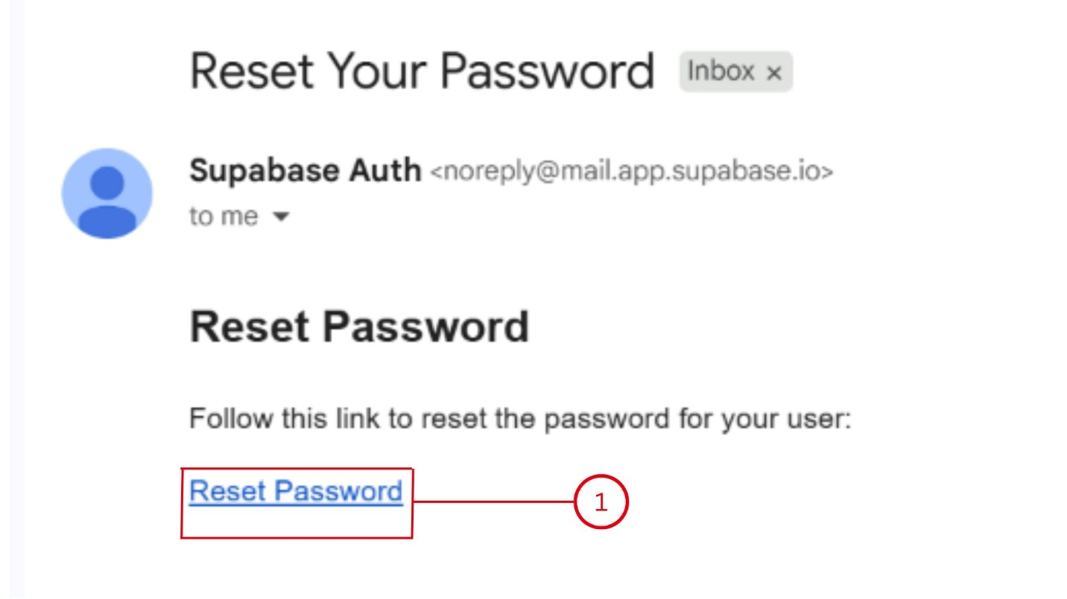
This is the password reset email sent after the user requests help from the Forgot password page.
- Reset Password link
The user clicks this Reset Password link to open the password reset page.
The email is sent by Supabase Auth, which means ReportFlow is using Supabase to manage account login and password recovery.

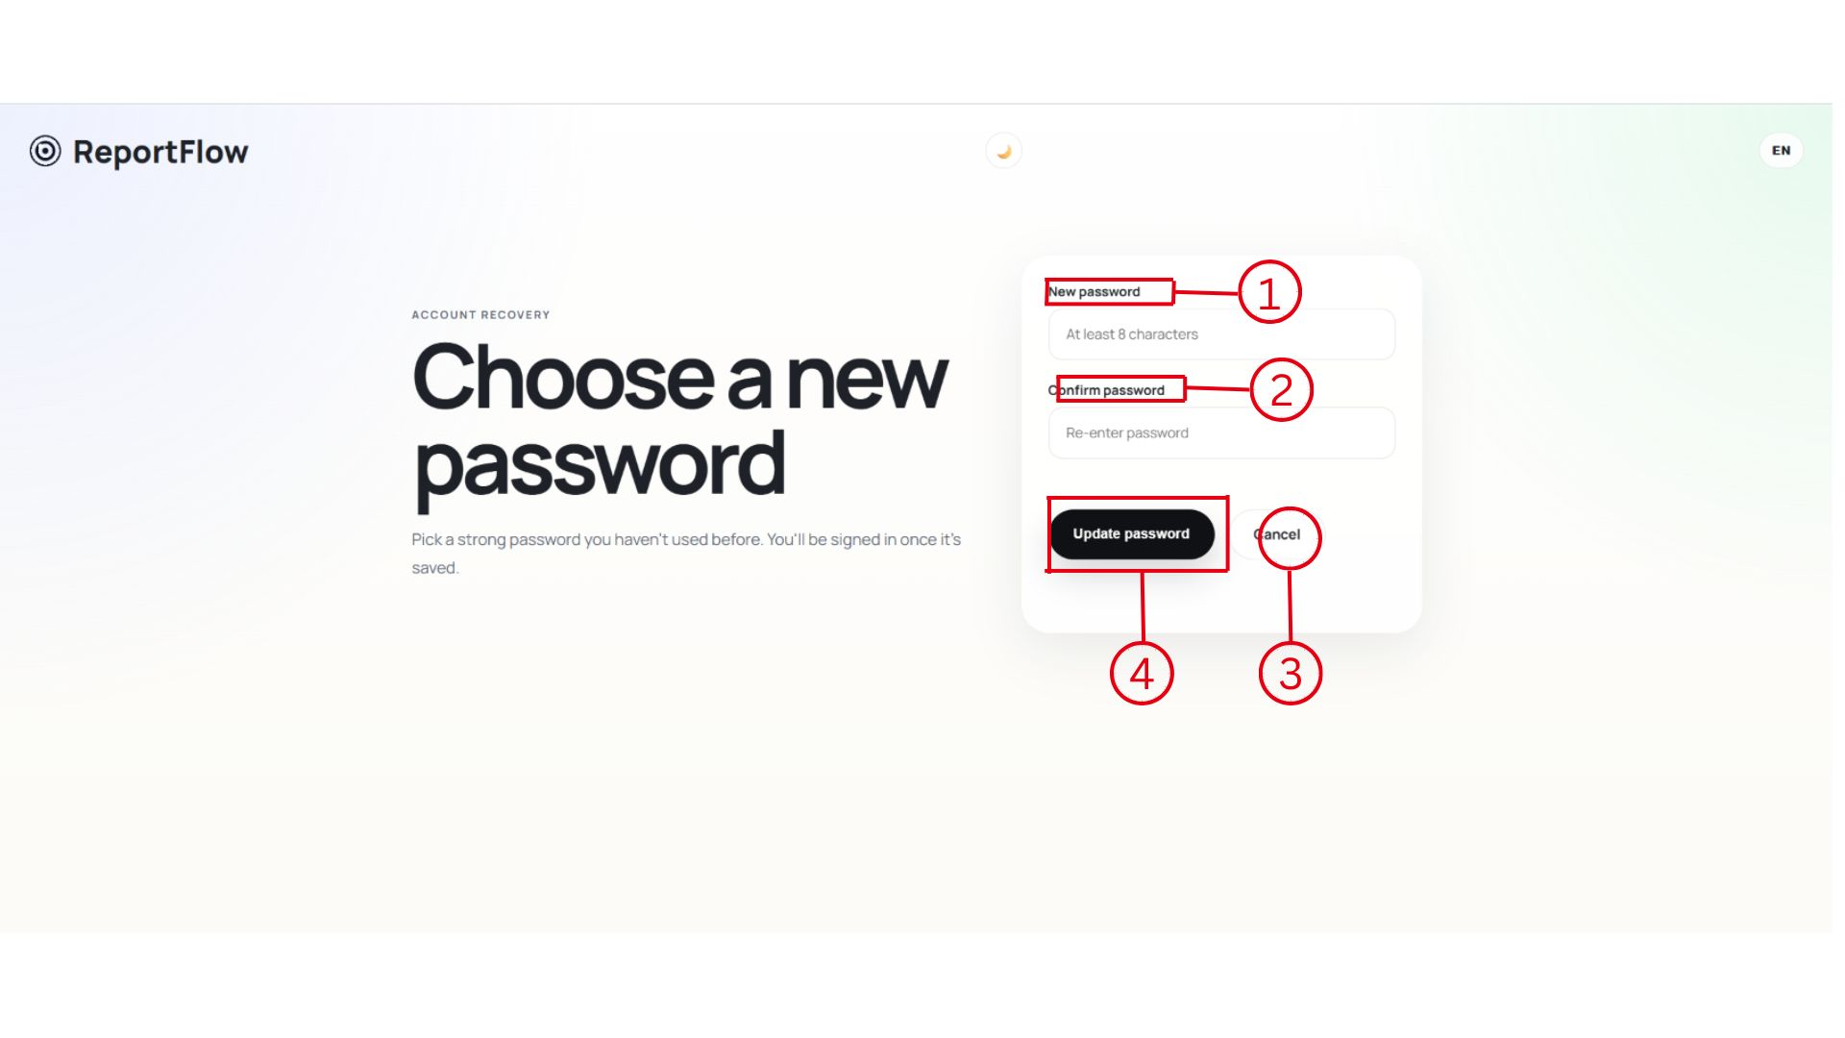
This is the ReportFlow new password page. It appears after the user clicks the Reset Password link from the email.
- New password
The user enters a new password here. The page says it should be at least 8 characters.
- Confirm password
The user re-enters the same password here. This helps make sure there are no typing mistakes.
- Cancel
This button cancels the password reset process. It may take the user back to the login page or previous page.
- Update password
After entering and confirming the new password, the user clicks Update password to save the new password.
The page also says the user will be signed in once the new password is saved.

- User dashboard: -
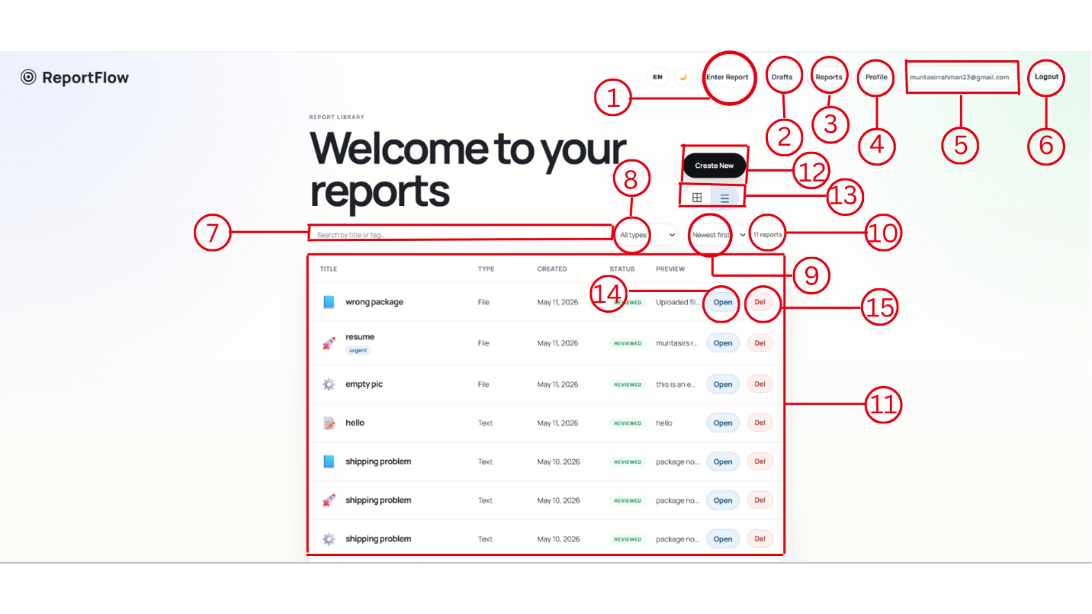
This is the ReportFlow report library page. It shows all the reports that the user has created or uploaded.
- Enter Report/ 12. Create New
This button takes the user to the create report page, where they can enter a new report.
- File: -
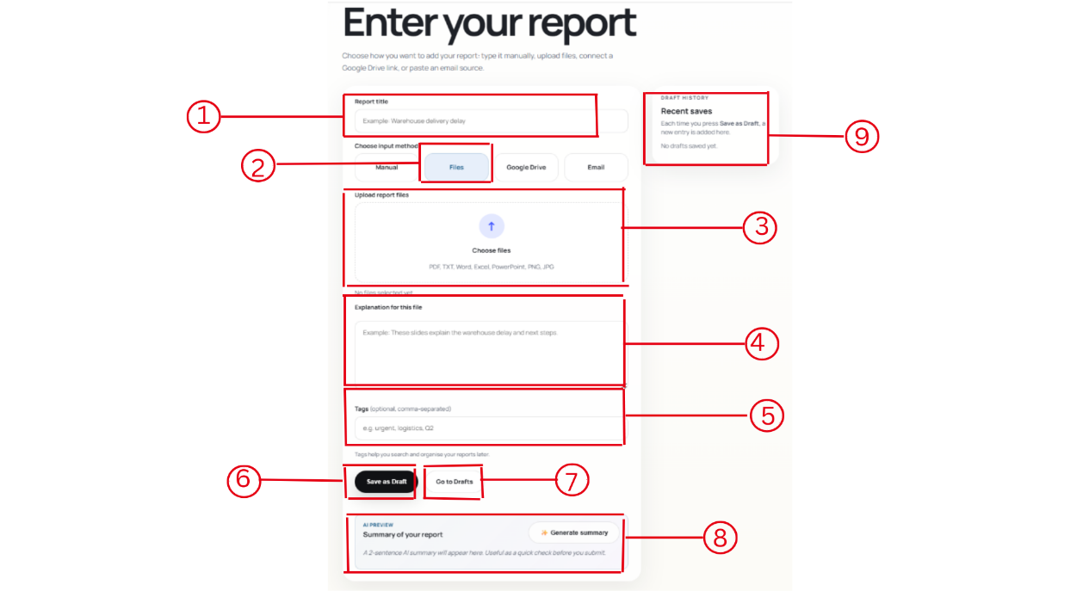
This is the ReportFlow enter report page. It is used to add a new report by typing it manually, uploading files, connecting Google Drive, or using an email source.
  - Report title
The user enters the title of the report here. For example, “Warehouse delivery delay.”
  - Input method
The user chooses how they want to add the report. The options are Manual, Files, Google Drive, and Email. In this image, Files is selected.
  - Upload report files
This section lets the user choose and upload files. Supported file types shown include PDF, TXT, Word, Excel, PowerPoint, PNG, and JPG.
  - Explanation for this file
The user can write a short explanation about the uploaded file. This helps describe what the file is about.
  - Tags
The user can add optional tags, separated by commas. Tags help organize and search reports later.
  - Save as Draft
This button saves the report as a draft so the user can continue working on it later.
  - Go to Drafts
This button takes the user to the drafts page, where saved drafts can be viewed.
  - AI Preview / Generate summary
This section can generate a short AI summary of the report. It helps the user quickly check what the report is about before submitting or saving it.
  - Draft history / Recent saves
This area shows recent saved drafts. Each time the user clicks Save as Draft, a new entry should appear here.
2. Manual: -
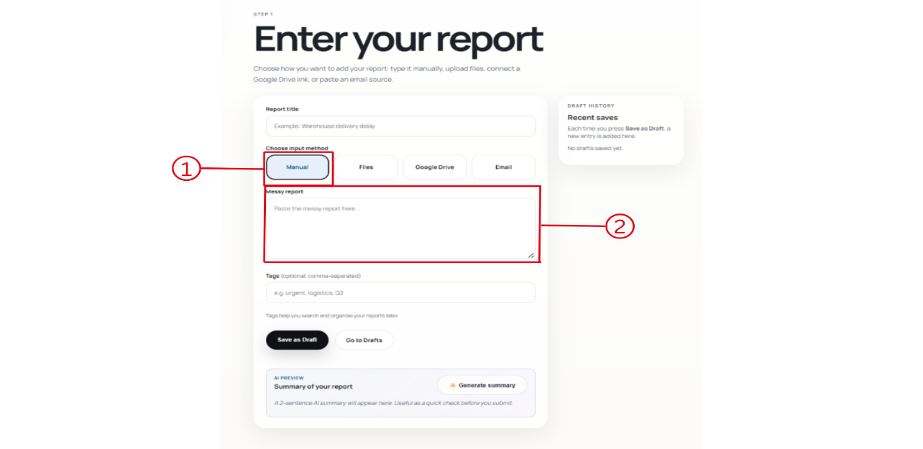
  - Manual input method
The Manual button is selected. This means the user wants to type or paste the report directly into the website instead of uploading a file, using Google Drive, or using email.
  - Messy report box
This is the large text box where the user enters the report content. The report can be rough or messy because the system can help summarize or organize it later.
Other parts on the page include the Report title field, Tags field, Save as Draft button, Go to Drafts button, Generate summary button, and Recent saves section.
3. Google Drive: -
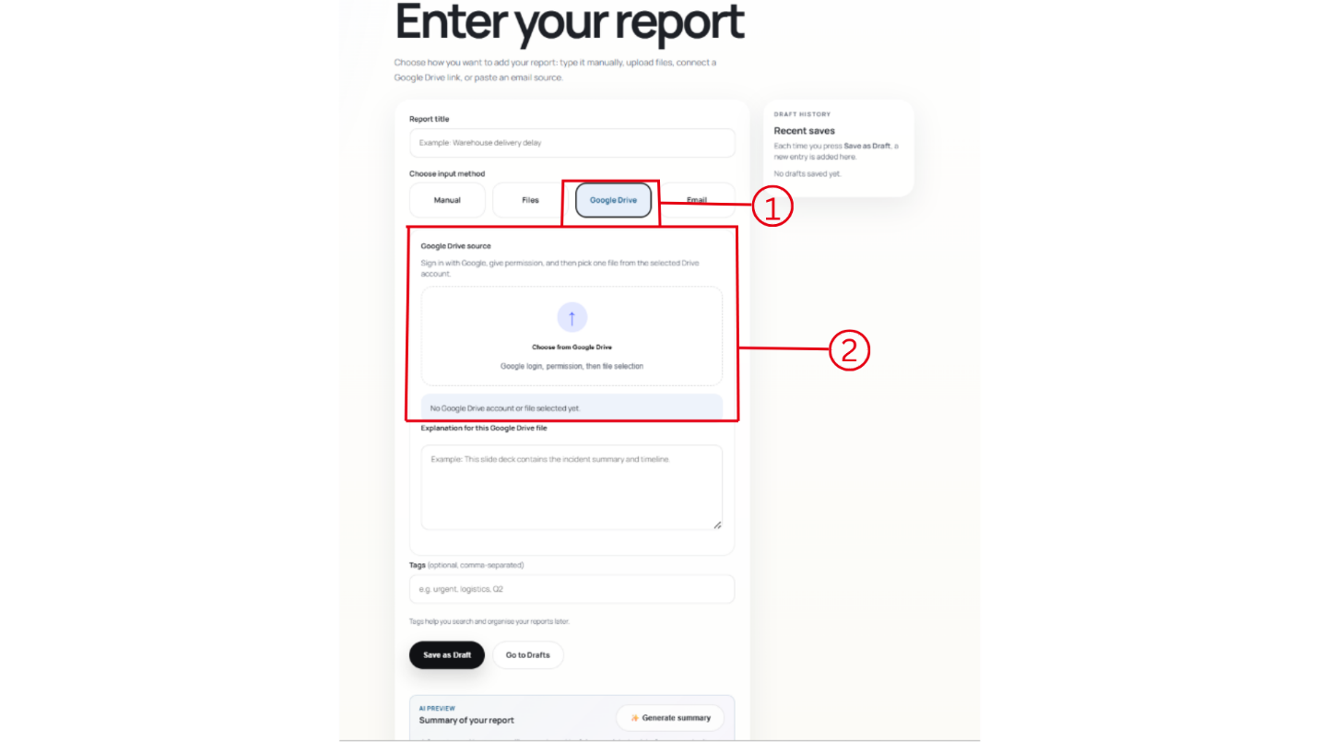

- Google Drive input method
The Google Drive button is selected. This means the user wants to add a report by choosing a file from their Google Drive account.
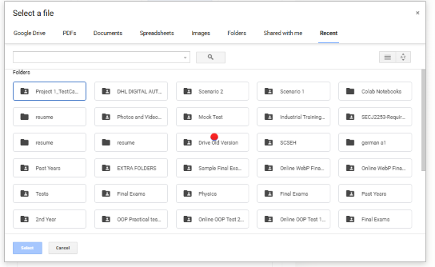
- Google Drive source box
This section is where the user connects to Google Drive and selects a file. The page says the user should sign in with Google, give permission, and then pick one file from the selected Drive account.
After choosing a Google Drive file, the user can also add an explanation, tags, save the report as a draft, or generate an AI summary.
4.. Email
- Gmail source box
This section lets the user choose a report source from Gmail. The user signs in with Google, gives permission, and then selects one email from the Gmail account.
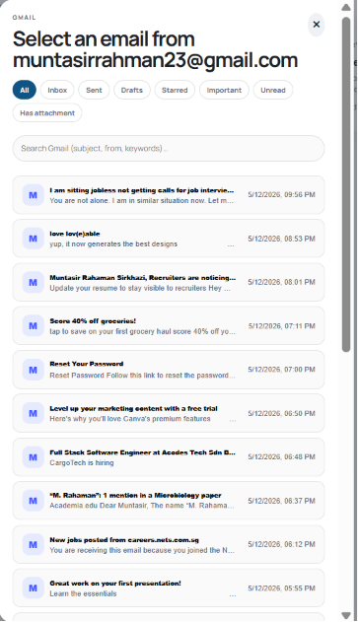
- Email input method
The Email button is selected. This means the user wants to create a report using content from an email.
After selecting an email, the user can add an explanation, tags, save the report as a draft, or generate an AI summary.
- Drafts
This opens the draft page, where unfinished reports can be viewed.
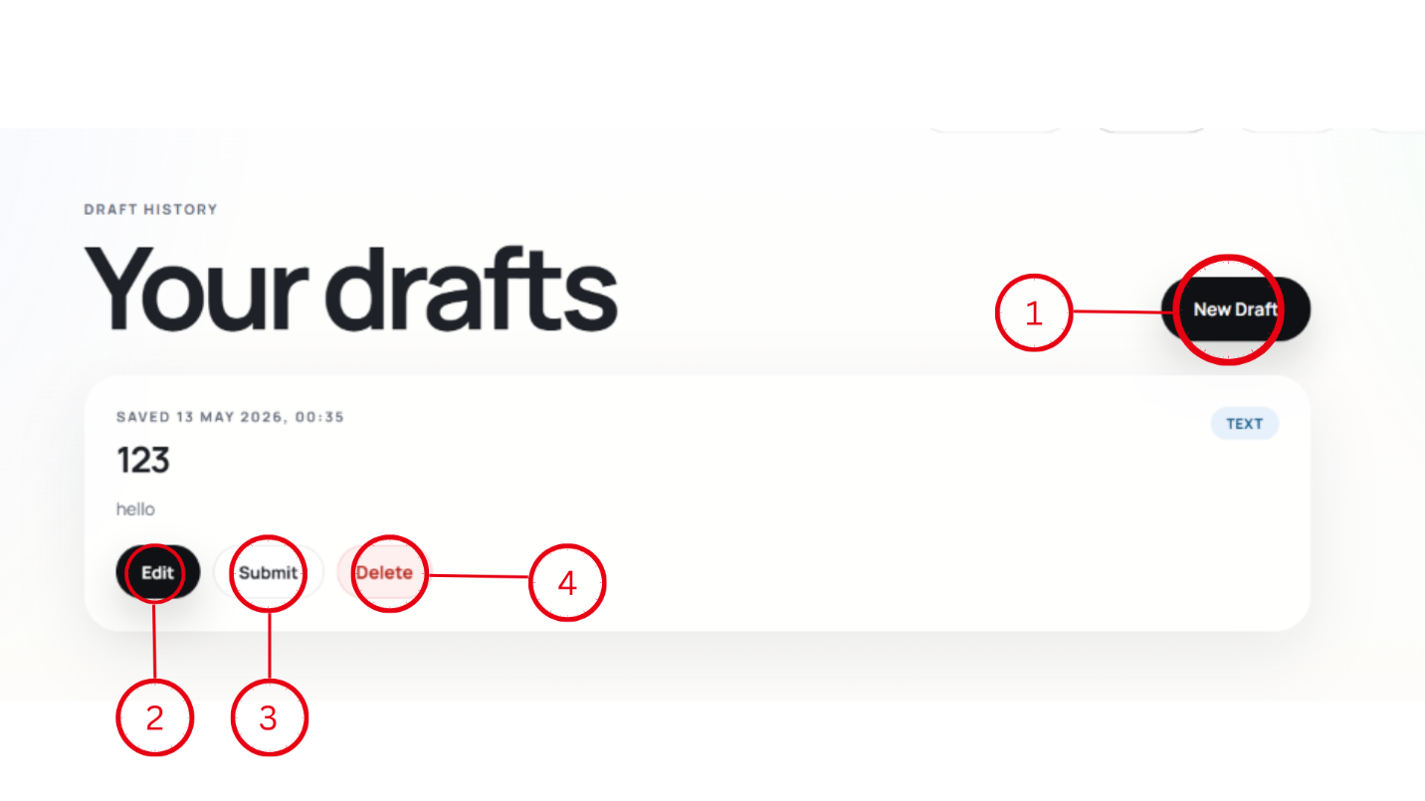

- Reports (this page)
This takes the user to the report library page, where saved reports are listed.

- Profile
This opens the user’s profile page.
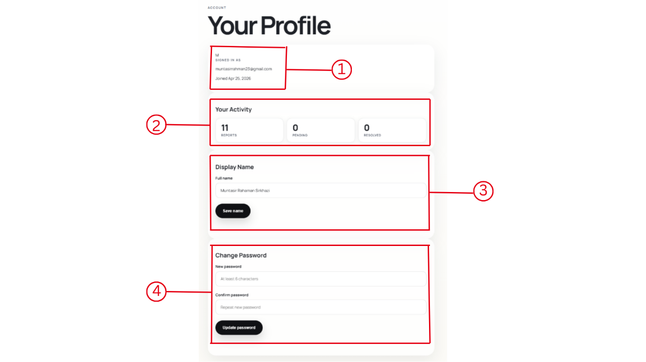
This is the ReportFlow profile page. It shows the user’s account details and lets the user update their name or password.
- Account information
This section shows the logged-in user’s account details, such as the user initial, email address, and the date the account was created.
- Your Activity
This section shows the user’s activity summary. In the image, it shows:
- 11 reports — the number of reports created or saved.
0 pending — no reports are currently pending.
0 resolved — no reports are marked as resolved.
- Display Name
This section lets the user change their full name. The user enters a name in the full name field and clicks Save name.
- Change Password
This section lets the user update their password from the profile page. The user enters a new password, confirms it, and clicks Update password.

- User ID / email
This shows the email address of the logged-in user.
- Logout
This logs the user out of ReportFlow.
- Search filter
This search box lets the user search reports by title or tag.
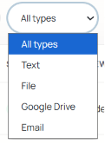
- Type filter
This dropdown lets the user filter reports by type, such as All types, Text, File, Google Drive, or Email.

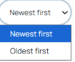
- Sort filter
This lets the user sort the reports, such as showing the newest files first or oldest files first.

- Number of reports
This shows how many reports are currently in the library.
- Report list/table
This is where the user can see their saved reports. The table shows details such as title, type, created date, status, and preview.
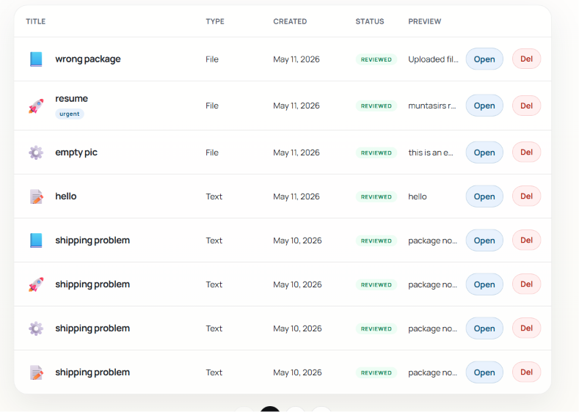
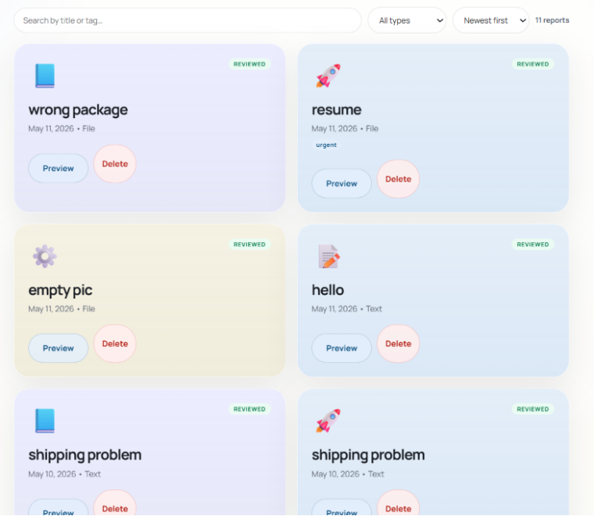
- View option
This lets the user switch between different display styles, such as card view and list/table view.

- Open
This button opens a selected report so the user can view its details.
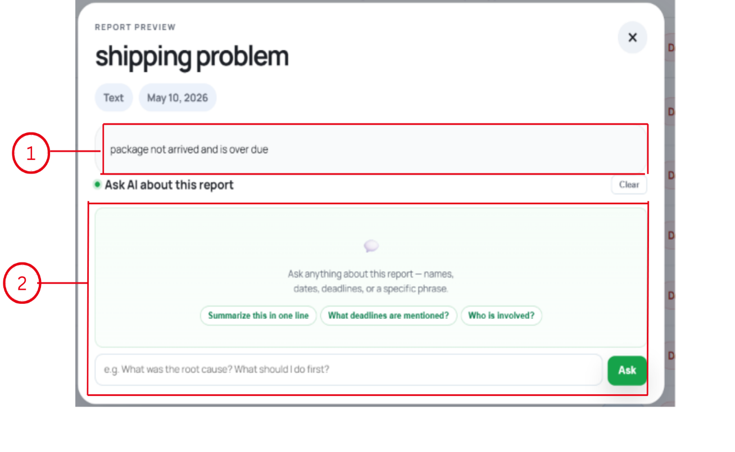
- Delete
This button deletes the selected report.
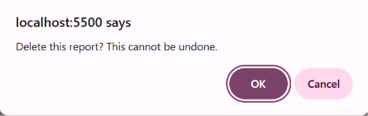

6. Admin Dashboard: -
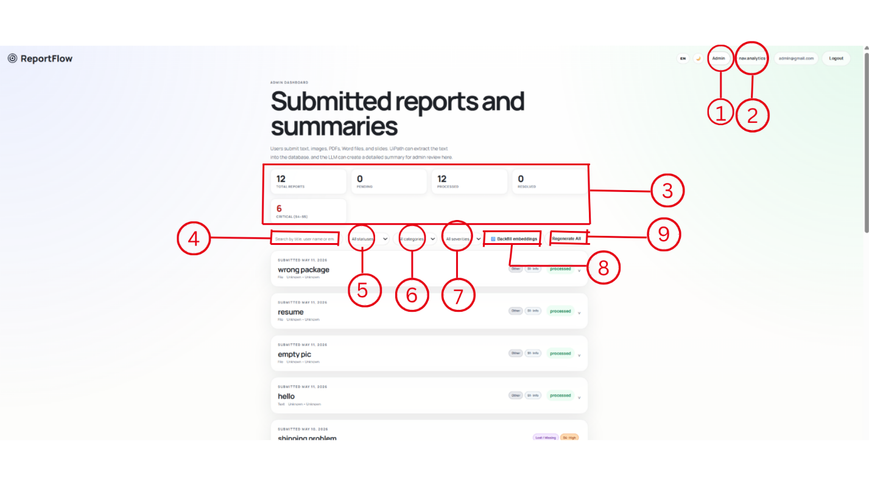
This is the ReportFlow admin dashboard page. It is used by an admin to review submitted reports and summaries.
1. Admin
This shows that the current user is using the admin dashboard.
2. nav.analytics
This is the navigation button for the analytics page or analytics section.
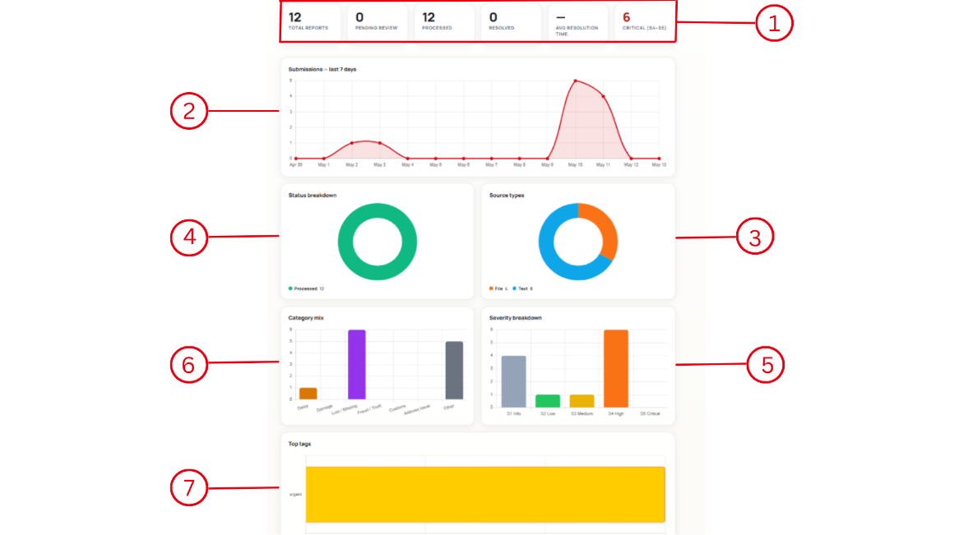
This is the ReportFlow analytics page. It helps the admin understand report activity using numbers and charts.
  - Summary statistics
This top section shows quick totals, such as:
12 total reports — all submitted reports.
0 pending review — reports waiting for admin review.
12 processed — reports already processed.
0 resolved — reports marked as resolved.
Average resolution time — how long reports usually take to be resolved.
6 critical — reports with the highest severity level.
  - Submissions chart
This line chart shows how many reports were submitted over recent days. It helps the admin see busy days or spikes in submissions.
  - Source types chart
This chart shows where reports came from, such as File or Text.
  - Status breakdown chart
This chart shows the report status distribution. In the image, the reports shown are processed.
  - Severity breakdown chart
This bar chart shows how many reports are in each severity level, such as info, low, medium, high, or critical.
  - Category mix chart
This chart groups reports by category, such as delay, lost/missing, recall/theft, damage, or other.
  - Top tags chart
This chart shows the most used tags. In the image, urgent is shown as a top tag.

3. Report statistics
This section shows summary numbers for the submitted reports. In the image, it shows:
12 total reports — total number of submitted reports.
0 pending — no reports are waiting for review.
12 processed — 12 reports have been processed.
0 resolved — no reports are marked as resolved.
6 critical — 6 reports are marked as critical.
4. Search bar
This lets the admin search reports by title, user name, or email.

5. Status filter
This dropdown filters reports by status, such as pending, processed, extracted, under review and resolved .
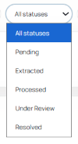
6. Category filter
This dropdown filters reports by category.
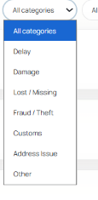
7. Severity filter
This dropdown filters reports by severity level, such as low, medium, high, or critical.
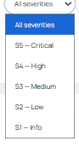
8. Backfill embeddings
Generate embeddings so duplicated can be detected
9. Regenerate All
This button is used to regenerate the summaries or AI outputs for all reports.

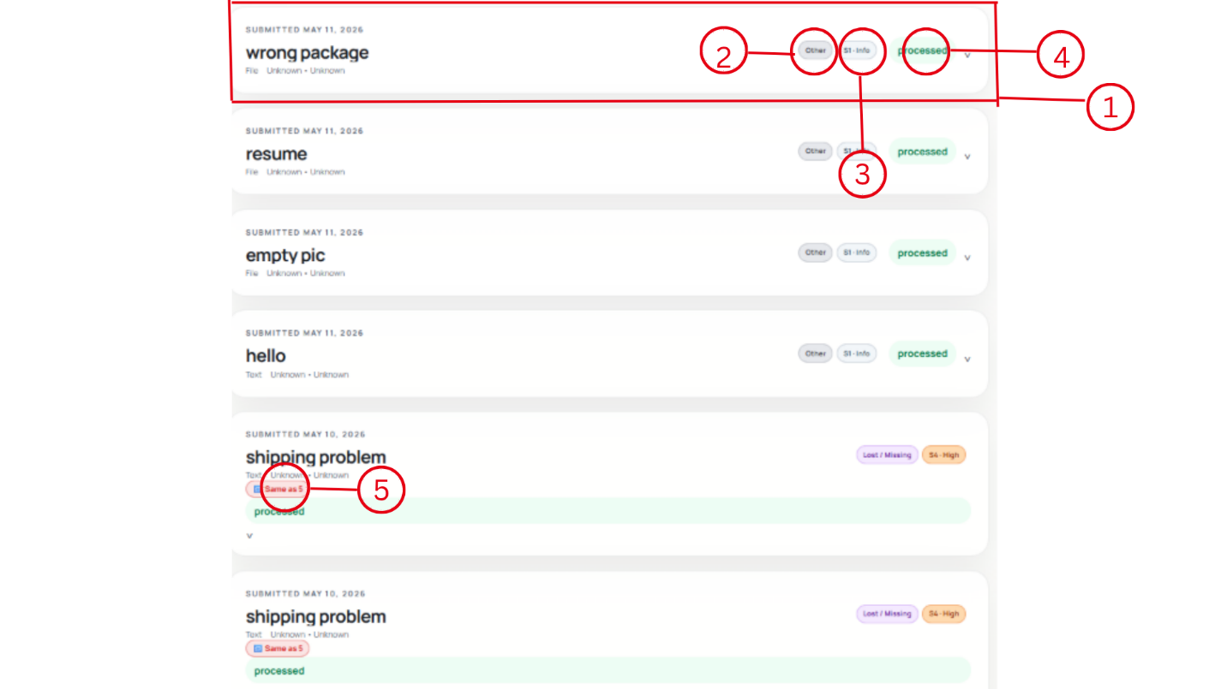
This section shows the submitted report list inside the ReportFlow admin dashboard. Each row represents one submitted report.
- Report row
This is one submitted report item. It shows the submission date, report title, source type, category, severity, and status.
- Category label
This label shows the report category. In the image, Other is shown as the category.
- Severity labels
This label shows the seriousness level of the report. In the image, S1 - Info means the report is informational or low severity.
- Status label
This shows the current processing status. In the image, processed means the report has already been processed by the system.
- Same as 5 labels
This label shows that the report is related to or similar to another report. For example, Same as 5 means it matches or duplicates report number 5.

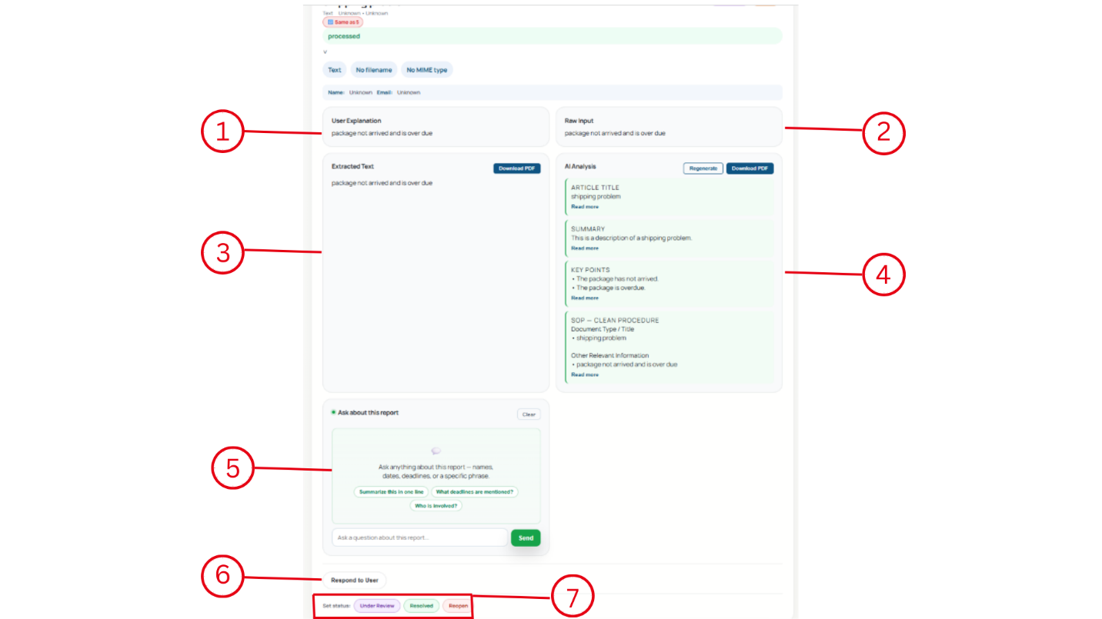

This is the expanded report details section in the ReportFlow admin dashboard. It appears after the admin opens or expands a submitted report.
- User Explanation
This shows the explanation written by the user when they submitted the report.
- Raw Input
This shows the original report content exactly as it was entered or uploaded by the user.
- Extracted Text
This section shows the text extracted from the submitted report or file. There is also a Download PDF button, which may allow the admin to download the extracted report content.
- AI Analysis
This section shows the AI-generated analysis of the report. It can include the article title, summary, key points, and other relevant information. The admin can also use Regenerate to create the analysis again or Download PDF to save it.
- Ask about this report
This is a chat-style question box. The admin can ask questions about the report, such as summarizing it, checking deadlines, or identifying who is involved.
- Respond to User
This button lets the admin write or send a response back to the user about the report.
- Set status
These buttons let the admin update the report status. The options shown are Under Review, Resolved, and Reopen.

Database: -
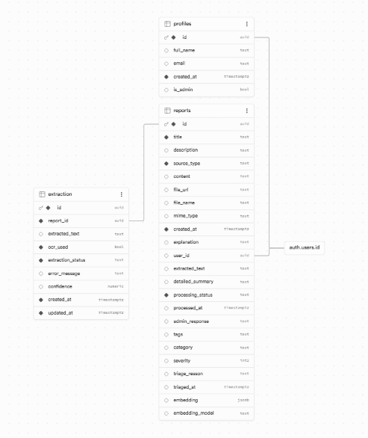
Table | Column | Type
profiles | id | uuid
profiles | full_name | text
profiles | email | text
profiles | created_at | timestamptz
profiles | is_admin | bool
reports | id | uuid
reports | title | text
reports | description | text
reports | source_type | text
reports | content | text
reports | file_url | text
reports | file_name | text
reports | mime_type | text
reports | created_at | timestamptz
reports | explanation | text
reports | user_id | uuid
reports | extracted_text | text
reports | detailed_summary | text
reports | processing_status | text
reports | processed_at | timestamptz
reports | admin_response | text
reports | tags | text
reports | category | text
reports | severity | int2
reports | triage_reason | text
reports | triaged_at | timestamptz
reports | embedding | jsonb
reports | embedding_model | text
extraction | id | uuid
extraction | report_id | uuid
extraction | extracted_text | text
extraction | ocr_used | bool
extraction | extraction_status | text
extraction | error_message | text
extraction | confidence | numeric
extraction | created_at | timestamptz
extraction | updated_at | timestamptz

UiPath: -
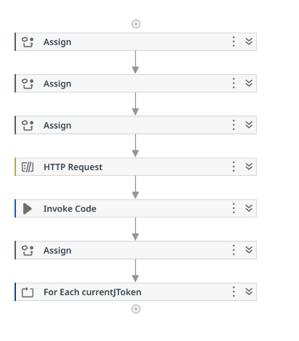
VARIABLES LIST:
Name | Type | Scope | Default
supabaseUrl | String | Main | ""
supabaseKey | String | Main | ""
dummyStr | String | Main | ""
httpResult | Object | Main | —
reportJson | String | Main | ""
jsonArray | JArray | Main | —
currentItem | JObject | Main | —
reportId | String | Main | ""
sourceType | String | Main | ""
fileUrl | String | Main | ""
fileName | String | Main | ""
contentText | String | Main | ""
mimeType | String | Main | ""
extractedText | String | Main | ""
processingStatus | String | Main | ""
ocrUsed | Boolean | Main | False
localFilePath | String | Main | ""
fileResponse | Object | Main | —
fileSize | Int32 | Main | 0
pptPdfPath | String | Main | ""
imagePath | String | Main | ""
loadedImage | Image | Main | —

MAIN SEQUENCE:

1. ASSIGN — Supabase URL
supabaseUrl = "https://your-project.supabase.co"

2. ASSIGN — Supabase Key
supabaseKey = "your-service-role-key"

3. ASSIGN — Create Files Folder
dummyStr = System.IO.Directory.CreateDirectory(
System.IO.Path.Combine(Environment.CurrentDirectory, "Files")
).FullName

4. HTTP REQUEST — GET from Supabase
Method = GET
URL = supabaseUrl + "/rest/v1/reports?processing_status=eq.pending&select=*"
Body = None

Headers:
apikey = supabaseKey
Authorization = "Bearer " + supabaseKey
Content-Type = "application/json"

Properties Output:
Response content = httpResult (Object)

5. INVOKE CODE — Extract JSON
Code:
reportJson = httpResult.GetType().GetProperty("TextContent").GetValue(httpResult).ToString()

Arguments:
httpResult | In | Object | httpResult
reportJson | Out | String | reportJson

6. LOG MESSAGE
Message = "Total records fetched"
Level = Info

7. ASSIGN — Parse JSON
jsonArray = Newtonsoft.Json.Linq.JArray.Parse(reportJson)

8. FOR EACH
Item = currentJToken
In = jsonArray
TypeArgument = Newtonsoft.Json.Linq.JToken

BODY OF FOR EACH:

8.1 ASSIGN — Cast to JObject
currentItem = DirectCast(currentJToken, Newtonsoft.Json.Linq.JObject)

8.2-8.7 ASSIGN — Extract fields
reportId = If(currentItem("id") IsNot Nothing, currentItem("id").ToString.Trim, "")
sourceType = If(currentItem("source_type") IsNot Nothing, currentItem("source_type").ToString.Trim, "")
fileUrl = If(currentItem("file_url") IsNot Nothing, currentItem("file_url").ToString.Trim, "")
fileName = If(currentItem("file_name") IsNot Nothing, currentItem("file_name").ToString.Trim, "")
contentText = If(currentItem("content") IsNot Nothing, currentItem("content").ToString.Trim, "")
mimeType = If(currentItem("mime_type") IsNot Nothing, currentItem("mime_type").ToString.Trim, "")

8.8-8.10 ASSIGN — Reset variables
extractedText = ""
processingStatus = ""
ocrUsed = False

8.11 LOG MESSAGE
Message = "Processing reportId: " + reportId
Level = Info

8.12 IF — sourceType = "text"
Condition = sourceType.ToLower.Trim = "text"

THEN:
Assign extractedText = contentText
Assign processingStatus = "success"

ELSE: → 8.13

8.13 IF — fileUrl or fileName empty
Condition = String.IsNullOrWhiteSpace(fileUrl) Or String.IsNullOrWhiteSpace(fileName)

THEN:
Assign extractedText = "Invalid file data"
Assign processingStatus = "failed"

ELSE: → 8.14

8.14 ASSIGN — Build localFilePath
localFilePath = System.IO.Path.Combine(
Environment.CurrentDirectory,
"Files",
fileName.Replace(" ","_"))

8.15 HTTP REQUEST — Download File
Method = GET
URL = fileUrl
Body = None
Headers: (empty for public bucket)

Properties:
Always save response as file = True
Output file name = fileName.Replace(" ","_")
Output file target folder = System.IO.Path.Combine(Environment.CurrentDirectory, "Files")
If file already exists = Replace
Response content = fileResponse

8.16 ASSIGN — Get file size
fileSize = CInt(New System.IO.FileInfo(localFilePath).Length)

8.17 IF — File valid
Condition = System.IO.File.Exists(localFilePath) AndAlso fileSize > 100

THEN: → 8.18

ELSE:
Assign extractedText = "No useful info detected"
Assign processingStatus = "failed"

8.18 IF — Is PDF?
Condition = fileName.ToLower.EndsWith(".pdf")

THEN:
Try Catch
TRY:
Read PDF Text
File Name = localFilePath
Text (Out) = extractedText
CATCH (exception):
Assign extractedText = ""
Log Message: "PDF error: " + exception.Message | Warn

IF String.IsNullOrWhiteSpace(extractedText)
THEN:
Try Catch
TRY:
Read PDF With OCR
File Name = localFilePath
└── UiPath Document OCR
Text (Out) = extractedText
CATCH (exception):
Assign extractedText = "No useful info detected"
Assign processingStatus = "failed"
Assign ocrUsed = True
ELSE:
Assign ocrUsed = False

ELSE: → 8.19

8.19 IF — Is Word?
Condition = fileName.ToLower.EndsWith(".doc") Or fileName.ToLower.EndsWith(".docx")

THEN:
Use Word Application Scope
File Path = localFilePath
└── Do
Read Text
Text (Out) = extractedText
Assign ocrUsed = False

ELSE: → 8.20

8.20 IF — Is Image?
Condition = fileName.ToLower.EndsWith(".png") Or
fileName.ToLower.EndsWith(".jpg") Or
fileName.ToLower.EndsWith(".jpeg") Or
fileName.ToLower.EndsWith(".bmp")

THEN:
Assign imagePath = localFilePath

Try Catch
TRY:
Load Image
File Name = imagePath
Output = loadedImage

Tesseract OCR
Image = loadedImage
Language = "eng"
Scale = 3
Text (Out) = extractedText

CATCH (exception):
Assign extractedText = "No useful info detected"
Assign processingStatus = "failed"
Log Message: "Image OCR error: " + exception.Message | Warn

Assign ocrUsed = True

ELSE: → 8.21

8.21 IF — Is PowerPoint?
Condition = fileName.ToLower.EndsWith(".ppt") Or fileName.ToLower.EndsWith(".pptx")

THEN:
Assign pptPdfPath = System.IO.Path.Combine(
Environment.CurrentDirectory, "Files",
System.IO.Path.GetFileNameWithoutExtension(fileName) + ".pdf")

Use PowerPoint Presentation
PresentationFilePath = localFilePath
└── Do
Save Presentation as PDF
Save as file = pptPdfPath
Replace existing = On

Try Catch
TRY:
Read PDF Text
File Name = pptPdfPath
Text (Out) = extractedText
CATCH (exception):
Assign extractedText = ""

IF String.IsNullOrWhiteSpace(extractedText)
THEN:
Read PDF With OCR
File Name = pptPdfPath
└── UiPath Document OCR
Text (Out) = extractedText
Assign ocrUsed = True
ELSE:
Assign ocrUsed = False

ELSE:
Assign extractedText = "Unsupported file type"
Assign processingStatus = "skipped"

8.22 IF — Final Validation
Condition = String.IsNullOrWhiteSpace(extractedText)

THEN:
Assign extractedText = "No useful info detected"
Assign processingStatus = "failed"

ELSE:
Assign processingStatus = "success"

8.23 ASSIGN — Build PATCH JSON safely
To: reportJson
Value: "{""extracted_text"": " + Newtonsoft.Json.JsonConvert.SerializeObject(extractedText) + ", ""processing_status"": """ + processingStatus + """}"

8.24 HTTP REQUEST — PATCH Supabase
Method = PATCH
URL = supabaseUrl + "/rest/v1/reports?id=eq." + reportId
Body = Text
Content-Type = application/json
Text = reportJson

Headers:
apikey = supabaseKey
Authorization = "Bearer " + supabaseKey
Content-Type = "application/json"
Prefer = "return=minimal"

Properties Output:
Response content = httpResult

8.25 LOG MESSAGE
Message = "PATCH complete for: " + reportId + " | Status: " + processingStatus
Level = Info

END FOR EACH

9. LOG MESSAGE — Done
Message = "All records processed successfully"
Level = Info

